**USER GUIDE TO USE AUTO PRICING CALCULATOR TOOL**

**Why this tool:**

ThisAUTO PRICING CALCULATOR tool is used to update the product price automatically in amazon.in whenever there any change in price in amazon.com.

Before this tool they used to update the prices manually which will take days to complete the work. But this tool completes the work in minutes.

**How it works:**

This auto pricing calculator takes ASINS as input and produces the fields like SP, MRP, MIN price and MAX price. Which are used in auto pricing to achieve **BUY BOX.**

**How to use it:**

**Step-1:-**Open Auto pricing calculator contains tool and paste the ASINS in insert your queries field if you have more than one ASIN.

**Step-2:-**click submit button, this will generate the downloadable file link and download the file using the download file button.

**Step-3:-**Now, open the downloaded excel sheet and it will display the updated pricing data.

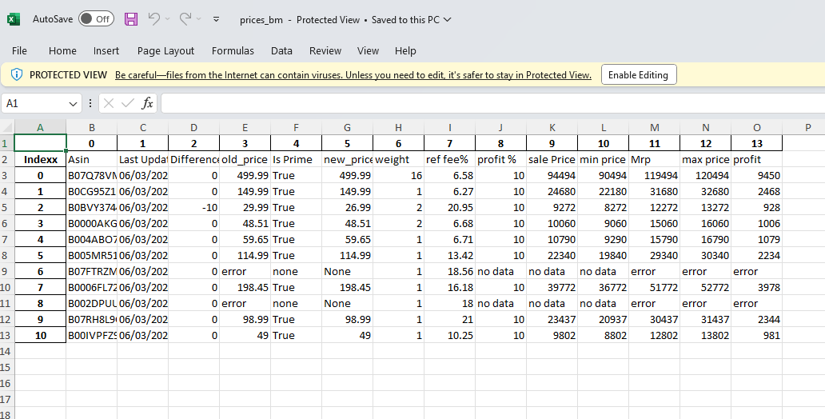

**Step-4:-**Otherwise, use quick search field to enter single ASIN.

**Step-5:-**This quick search will directly display theupdated pricing data in the current page without any external file.

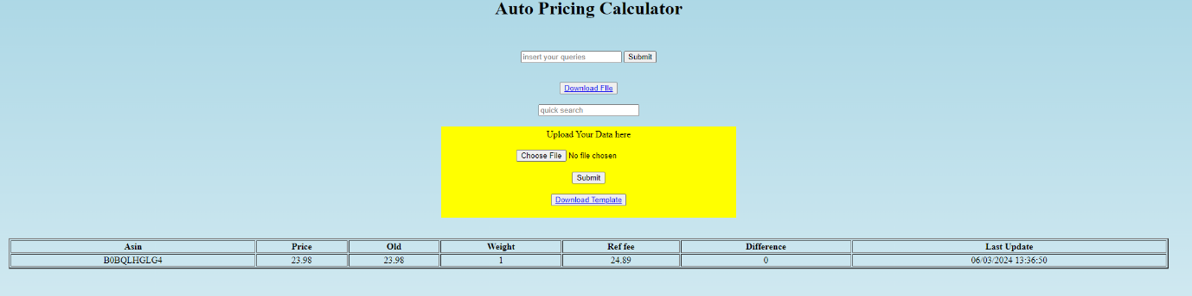

**Any Updates (If required):**